CL2005

Database Systems Lab
Animal Hospital and Shelter Management System

3. Paw Track

Semester Fall 2025

Submitted to: Sir Ahsan Shakeel

Submitted by:
CY-A
Eman Akbar
22i-1588
Sarita Sangrez
23i-2088
Amna Ali
23i-2067
Submission Date:
Deadline: 05/10/25

Contents
Section 1: D1 Feedback Review & Changes Made 3
1.1 Summary of Feedback Received 3
1.2 Changes Made Based on Feedback 3
1.3 Change Log Table 4
1.4 Updated Modelling Assumptions 4
Section 2: Relational Design & Normalization 5
2.1 Updated EERD Diagram 5
2.2 Relational Schema 5
2.3 Relational Diagram 8

Section 1: D1 Feedback Review & Changes Made

Summary of Feedback Received
During the evaluation of Deliverable 1 (D1), our team received positive feedback regarding the structure, entity selection, and clarity of assumptions. However, the evaluator identified three specific issues requiring revision:
Issue 1 — Unrealistic NFR (Performance)
Our NFR-1 stated sub-second lookup speeds for 5,000+ records. The evaluator noted this is unnecessary and unrealistic for a semester-level database with only 10–15 rows per table.
Issue 2 — Out-of-Scope NFR (Medical Record Retention)
NFR-6 proposed mandatory retention of medical and adoption records for at least 5 years.
This implies archiving/versioning and historical tables — beyond course scope.
Issue 3 — Missing Authentication Attributes in Staff
The evaluator noted that the Staff entity lacked attributes required for login functionality:
- Username
- Password (hashed)
All other ER/EER modelling elements were approved.
1.2 Changes Made Based on Feedback
Revision 1 — Removal of NFR-1 (Performance)
This requirement was removed entirely.
Revision 2 — Removal of NFR-6 (Compliance / Record Retention)
Converted to a non-system organizational policy rather than an enforced system rule.
Revision 3 — Added Authentication Attributes to Staff
We added the following attributes:
- Username (unique)
- PasswordHash (hashed SHA-1 stored)
This supports login + role-based access control.

Change Log Table

Reviewer Comment / Observation | Action Taken / Revision Made
NFR-1 (Performance) unrealistic for semester-level dataset. | Removed NFR-1 from the NFR list.
NFR-6 (Compliance/Retention) requires extra historical tables beyond scope. | Removed NFR-6 to maintain realistic project scale and reformulated it as a company policy rather than a system NFR.
Staff entity missing login attributes. | Added Username and Password Hash to Staff.
ER/EER design generally correct. | No major changes required; clarified naming/assumptions.

Updated Modelling Assumptions
- Every Staff member has a unique username and securely hashed password (PasswordHash).
- OccupiedCount in ShelterRoom is stored and updated manually (not derived).
- Age is derived from DateOfBirth at query-time and not physically stored.
- Adoption requires valid existing Animal + Adopter.
- Only Veterinarians conduct medical treatments and appointments.

Section 2: Relational Design & Normalization
This section presents the relational schema derived from the approved ER/EER diagram (after applying evaluator feedback). All entities, relationships, ISA hierarchies, and weak entities are mapped into relational tables with appropriate keys and constraints.

2.1 Updated EERD Diagram
(added username and passwordHash attribute)
The final enhanced EERD includes:
- ISA hierarchy:
Staff → Admin, Veterinarian, Volunteer
- Adoption modeled with surrogate key (AdoptionID)
- ShelterRoom stores OccupiedCount as a normal attribute
- Authentication attributes added to Staff:
  - Username
  - PasswordHash
- Animal–Volunteer M:N relationship resolved via VolunteerAnimal
- All FKs use cascading rules (ON DELETE CASCADE, ON UPDATE CASCADE)

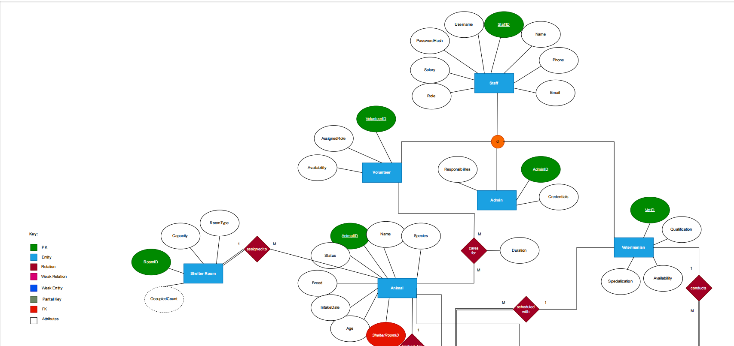

2.2 Relational Schema
1. Animal
- Stores information about animals in the shelter.
- AnimalID is the primary key.
- ShelterRoomID is a foreign key referencing ShelterRoom.
- Age is a derived attribute (calculated from DateOfBirth at query time).
2. Adopter
- Stores information about people adopting animals.
- AdopterID is the primary key.
- Email is unique to prevent duplicate records.
3. Adoption (Weak Entity)
- Records the adoption of an animal by an adopter.
- Depends on both Animal and Adopter for existence.
- Each animal can be adopted only once (AnimalID is unique).
- AdoptionFile stores the file path of the adoption document.
4. Staff (Superclass)
- Generalized entity for all staff members.
- Attributes include StaffID (PK), name, contact details, role, username, and password.
- Role defines the subclass: Admin, Veterinarian, or Volunteer.
5. Admin (ISA Subclass)
- Salaried staff managing shelter operations.
- AdminID is both PK and FK referencing StaffID.
6. Veterinarian (ISA Subclass)
- Licensed veterinarians who perform treatments and appointments.
- VetID is both PK and FK referencing StaffID.
7. Volunteer (ISA Subclass)
- Non-salaried staff assisting in animal care.
- VolunteerID is both PK and FK referencing StaffID.
8. Treatment
- Stores medical treatments for animals.
- Each treatment involves one Animal and one Veterinarian.
9. Appointment
- Scheduled meetings between an animal and a veterinarian.
- Each appointment is linked to exactly one animal and one veterinarian.
10. ShelterRoom
- Stores details of shelter rooms.
- OccupiedCount is derived from the number of animals assigned and is not physically stored.
11. VolunteerAnimal (Associative Table)
- Represents the many-to-many relationship between volunteers and animals.
- Includes descriptive attributes like AssignedDate and HoursPerWeek.
- Composite primary key: (VolunteerID, AnimalID).
Note: Age of an animal is a derived attribute calculated from DateOfBirth. In MySQL, non-deterministic functions such as CURDATE() or NOW() cannot be used in STORED generated columns. To avoid errors, we do not store Age as a column in the table. Instead, the age is calculated dynamically at query time.

2.3 Relational Diagram

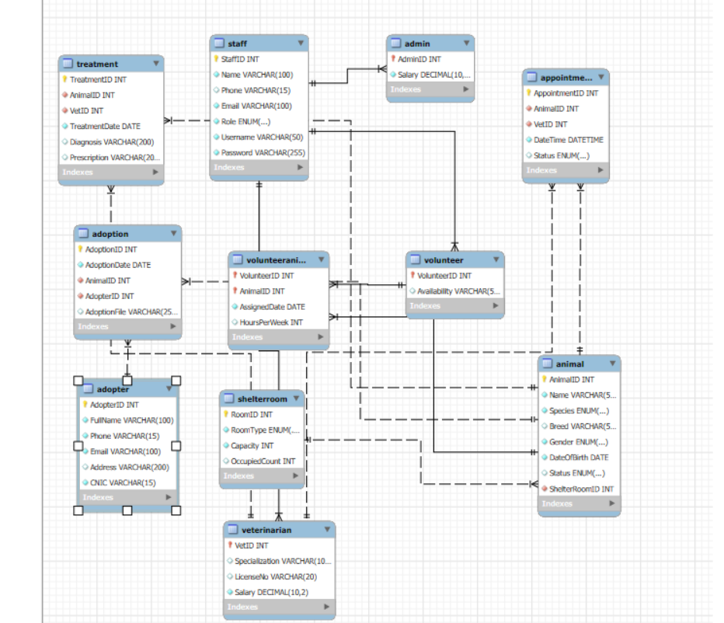
2.4 Referential Integrity Rules
All foreign keys use:
ON DELETE CASCADE
ON UPDATE CASCADE
This ensures:
- Deleting a Staff row deletes the corresponding Admin/Vet/Volunteer record
- Deleting an Animal deletes Adoption, VolunteerAnimal, Appointment, and Treatment rows
- Updating IDs propagates to all dependent tables

2.4 Normalization (1NF, 2NF, 3NF)
1NF
- All values are atomic
- No multivalued attributes
- PKs uniquely identify records
✔ Achieved.
2NF
- No partial dependencies
- Only composite key table: VolunteerAnimal
→ Non-key attributes depend on the whole composite key
✔ Achieved.
3NF
- No transitive dependencies
- Non-key attributes depend only on their table's PK
- Role in Staff is a safe categorical attribute, not a determinant
✔ Achieved.

SECTION 3 — Node.js Workflow
This section explains how data insertion is implemented through the Node.js application using Express.js, MySQL2 prepared statements, EJS forms, and express-validator. The goal of the application layer in D2 is to support Create operations across key entities in a secure, validated, and constraint-safe manner.
3.1 Overview of System Architecture
The Node.js application follows a modular MVC-inspired structure:
pawtrack-node/
│ app.js
│ db.js
│
├── routes/
│ animals.js
│ adopters.js
│ adoptions.js
│ treatments.js
│ appointments.js
│ staff.js
│
├── views/
│ *.ejs (forms, success pages, error pages)
│
└── public/
Key Components:
- Express.js — handles routing and form submissions
- EJS — renders server-side HTML templates
- MySQL2 — executes parameterized prepared statements
- express-validator — performs server-side validation
- dotenv — loads database credentials securely
- crypto (SHA-1) — hashes staff passwords before insertion

3.2 Workflow for Data Insertion
All insert operations follow the same workflow:
- User opens a form (e.g., /animals/new)
- EJS template displays the form
- User submits data
- express-validator validates all input fields
- If validation fails →
  - errors re-rendered on the form
- If validation succeeds →
  - Node runs a prepared SQL statement
- If database constraints fail:
  - EJS error page is displayed
- If insertion succeeds:
  - success page is displayed with navigation options

3.3 Validation Logic
All forms use strong validation to ensure data integrity.
Example for Animal:
- Name must contain only letters and spaces
- Species and Gender must match ENUM values
- Breed must not be empty
- Date of birth cannot be in the future
- RoomID must exist in ShelterRoom
- Status defaults to "Available"
Example for Staff:
- Unique username + email
- Password must be ≥ 6 characters
- Password hashed before storage
- Additional fields required based on role:
  - Admin → salary
  - Veterinarian → specialization, license
  - Volunteer → availability
Example for Adoption:
- Animal must exist and must not already be adopted
- Adopter must exist
- Valid date
- Optional file path

3.4 Prepared Statements (MySQL2)
The application uses prepared statements for security and reliability:
await pool.execute(
"INSERT INTO Animal (Name, Species, Breed, Gender, DateOfBirth, Status, ShelterRoomID)
VALUES (?, ?, ?, ?, ?, ?, ?)",
[name, species, breed, gender, dateOfBirth, status, shelterRoomID]
);
Benefits:
- Prevents SQL injection
- More efficient execution
- Ensures predictable handling of strings/dates

3.5 Role-Based Subtype Insertions (Admin, Vet, Volunteer)
The Staff insertion route automatically inserts into the appropriate subtype table:
Example:
If Role = 'Veterinarian', then:
- Insert row into Staff
- Retrieve generated StaffID
- Insert into Veterinarian (VetID = StaffID)
Same logic applies for Admin and Volunteer.
This ensures the ISA hierarchy is respected at the database level.

3.6 Handling Database Constraint Errors
Typical DB errors handled:
- ER_DUP_ENTRY
(duplicate email or username)
- Foreign key violations
(entering invalid AnimalID or AdopterID)
- ENUM constraint errors
(invalid species or appointment status)
Example error message:
“Email or username already exists (UNIQUE constraint violation).”
All errors are caught and displayed through error.ejs.

3.7 Success and Error User Interfaces
Success page (success.ejs) provides:
- A green success message
- A link back to home
- A link to “Add Another” (dynamic based on route)
Error page displays:
- Red error box
- Clear explanation from validator/DB
- No technical stack traces shown

3.8 Forms Implemented in D2
The following entities have complete working insertion pipelines:
- Animal
- Adopter
- Adoption
- Treatment
- Appointment
- Staff
  - Auto-inserts into Admin / Vet / Volunteer subtypes

3.9 Screenshots of entity wise entries
Node js setup:
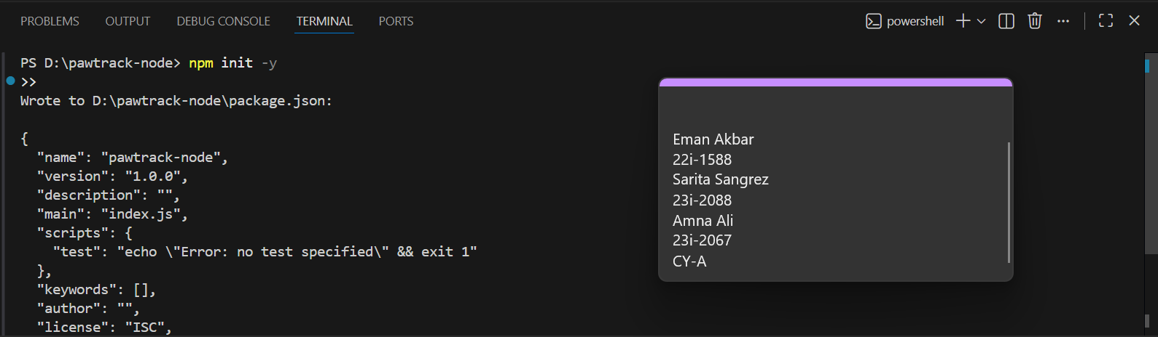
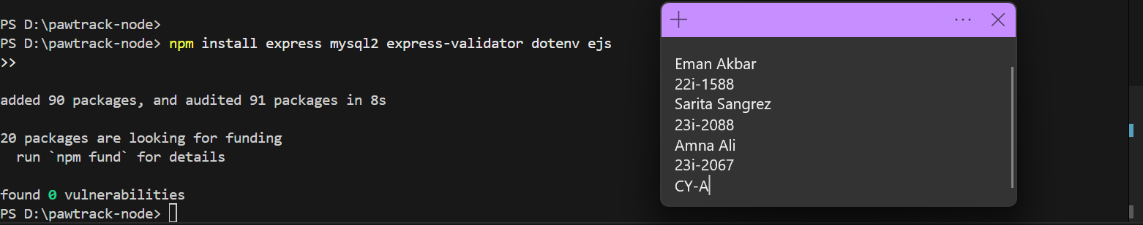
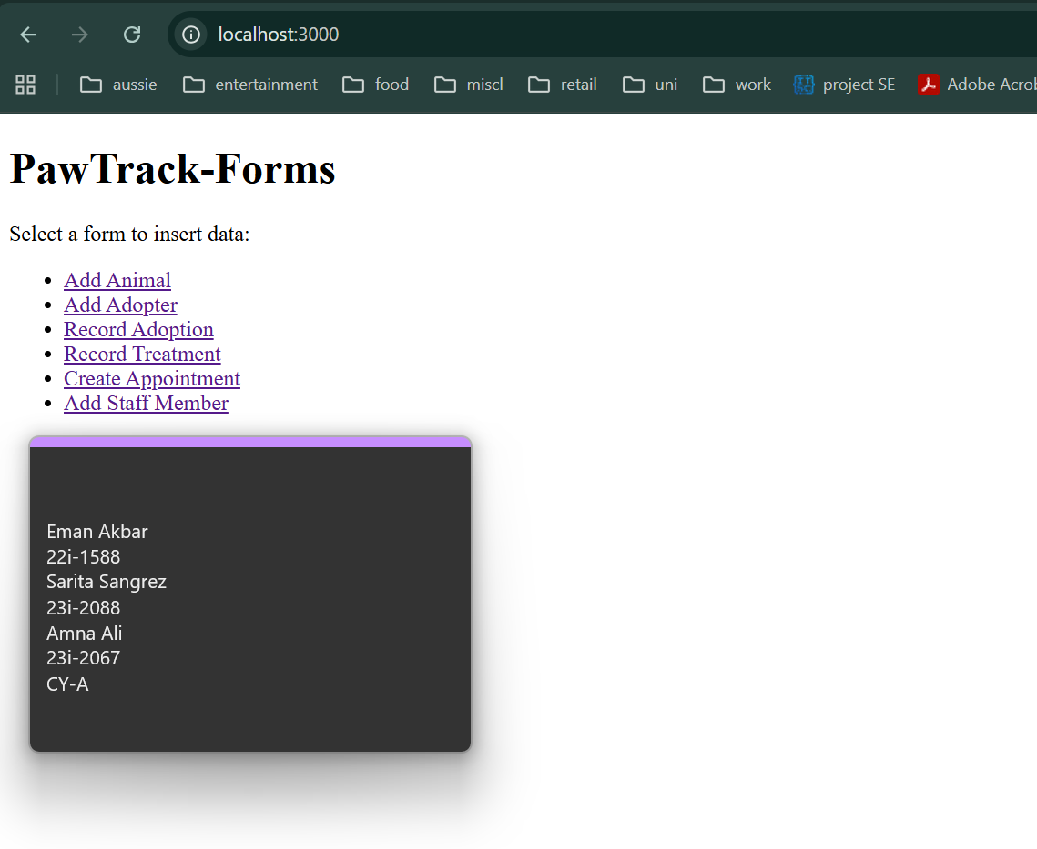
Animal Entity:
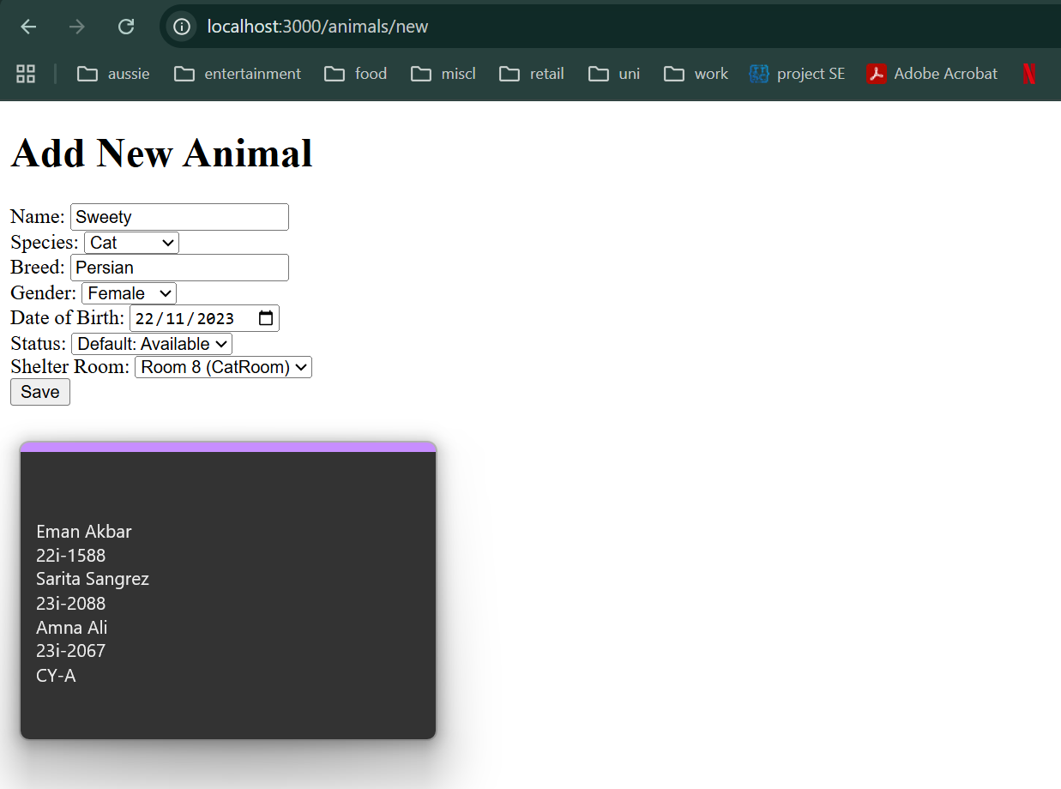
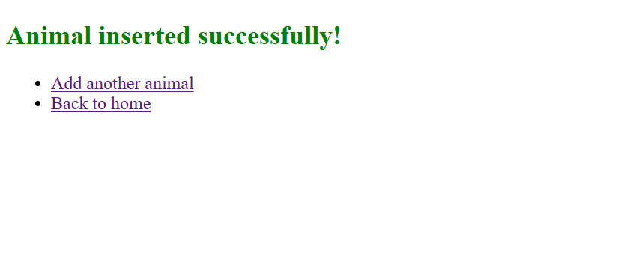
Validation check:
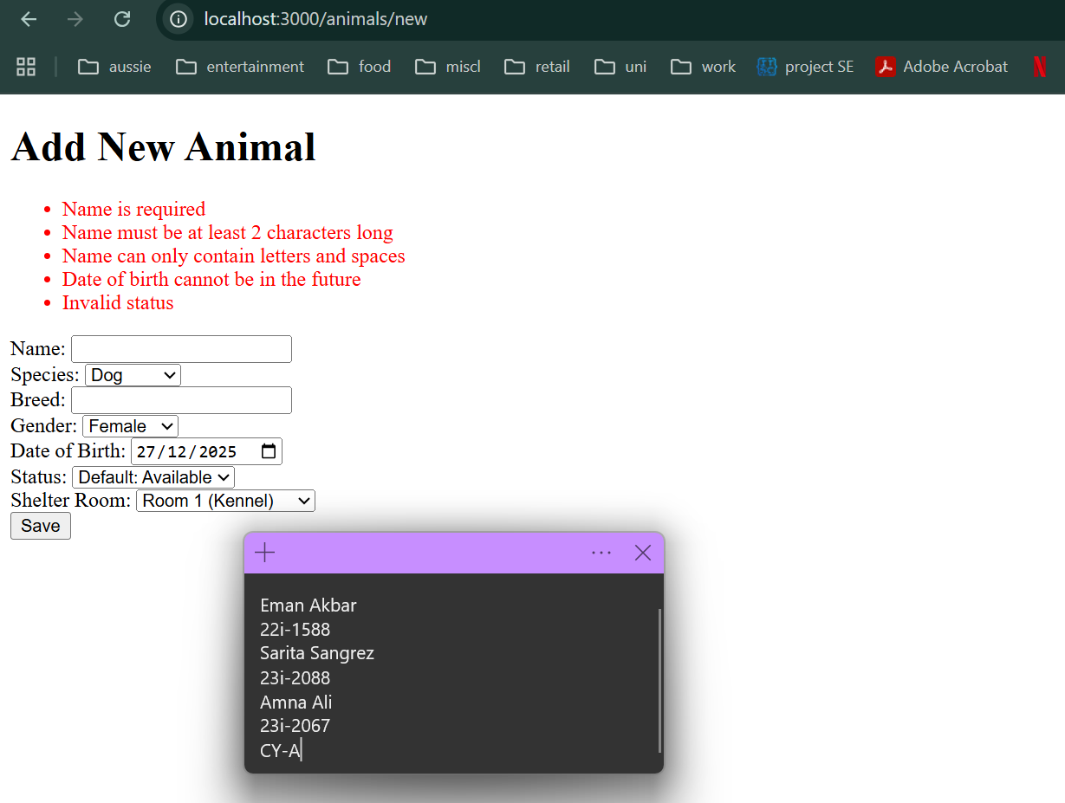
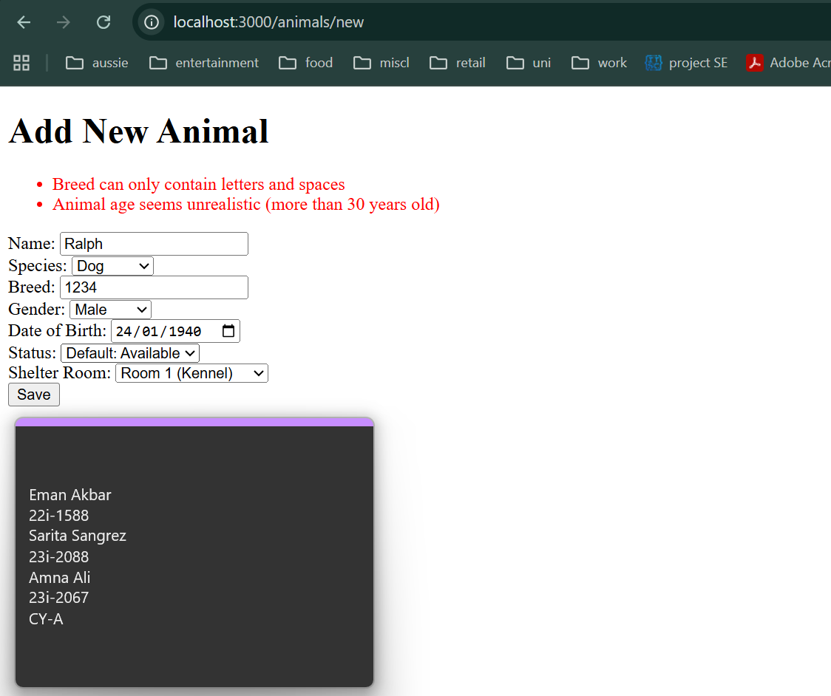

Staff Entity:
  - Admin
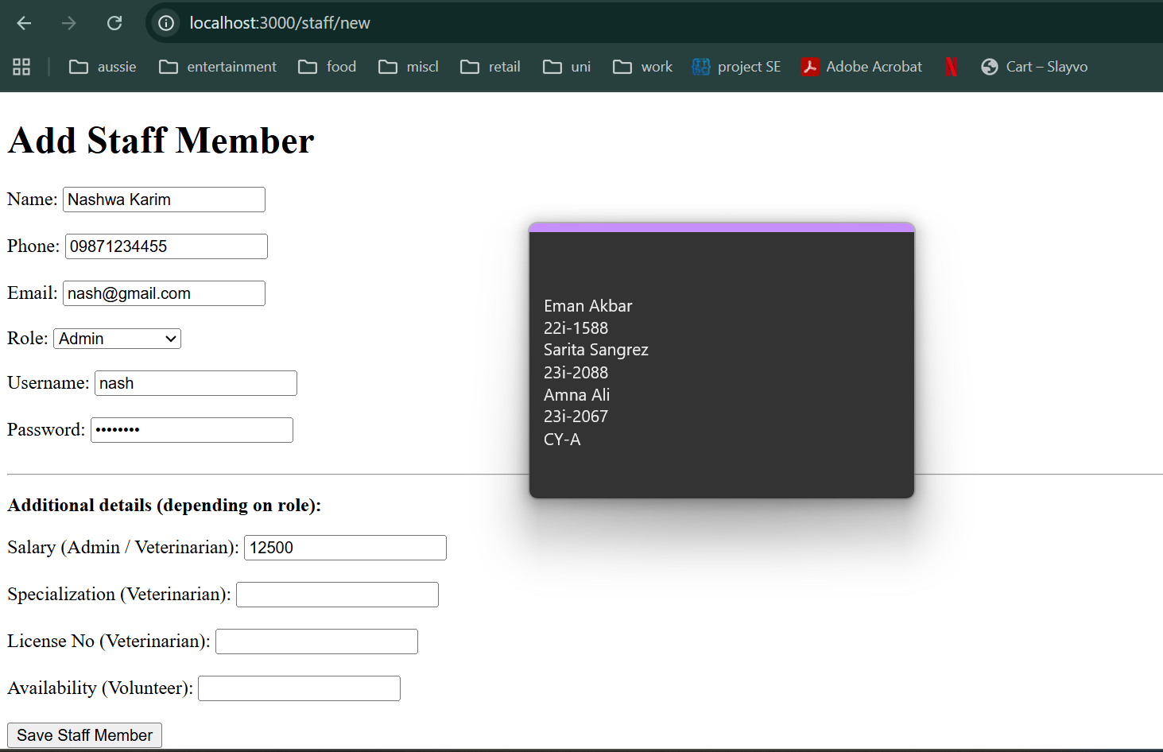
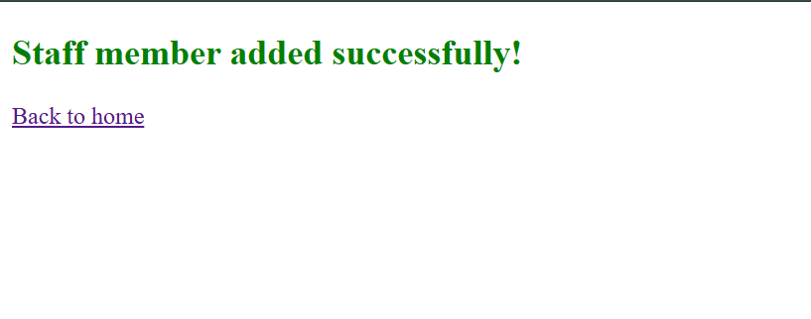
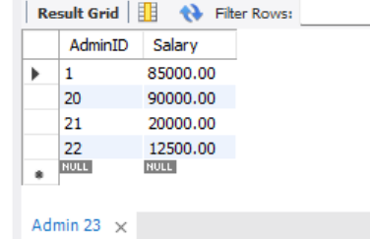Admin table
  - Vet
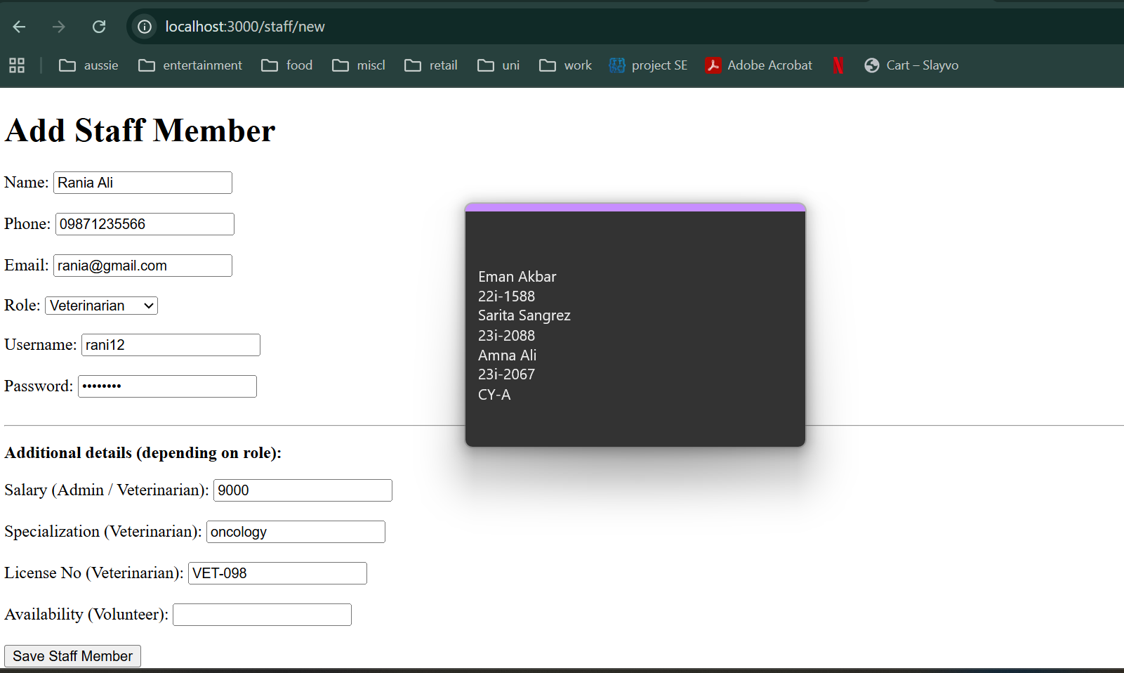
In staff table

In Vet table: with hashed password
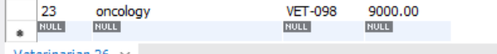
  - Volunteer
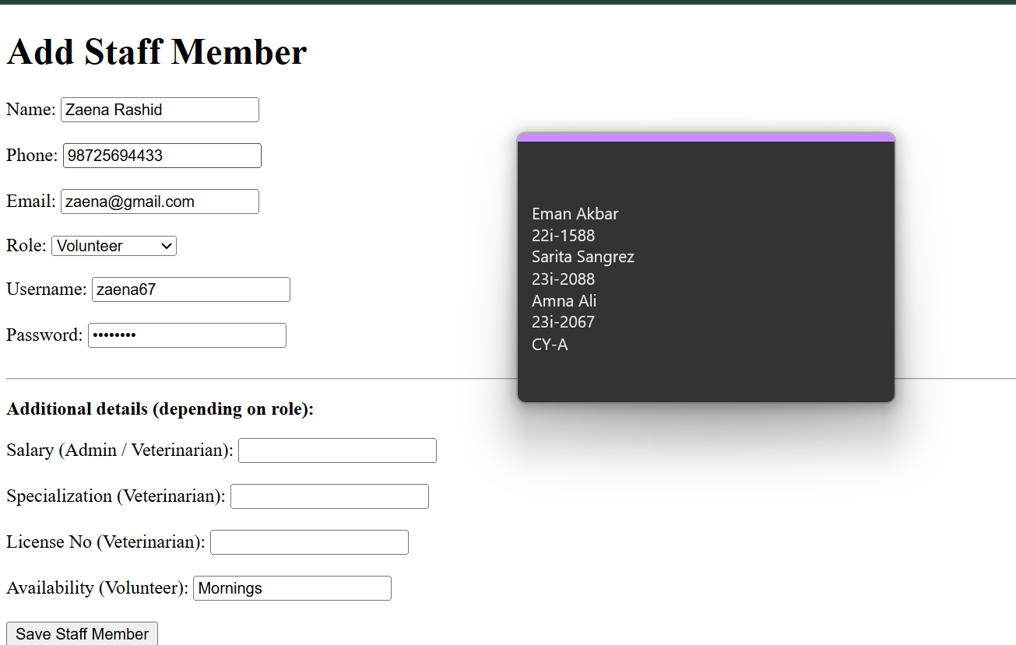
Volunteer table
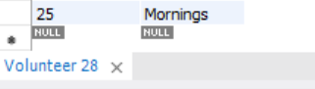
- All staff members are added to the staff table
Validation Check:
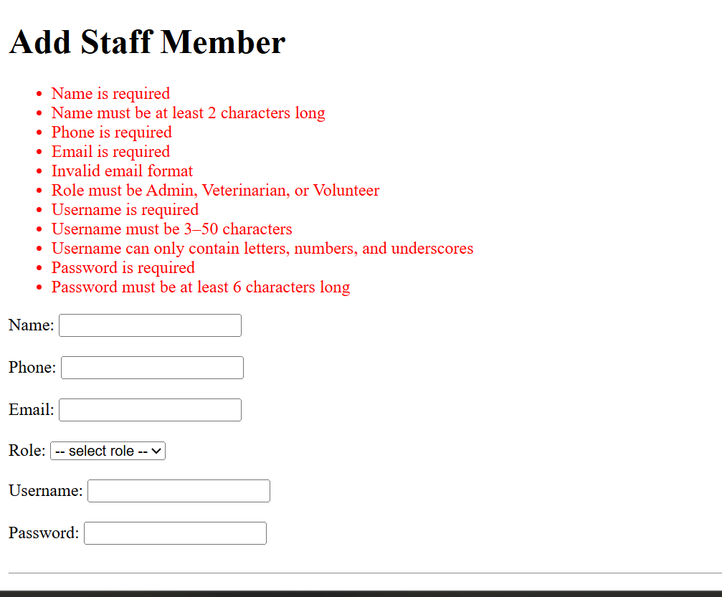
Adopter:
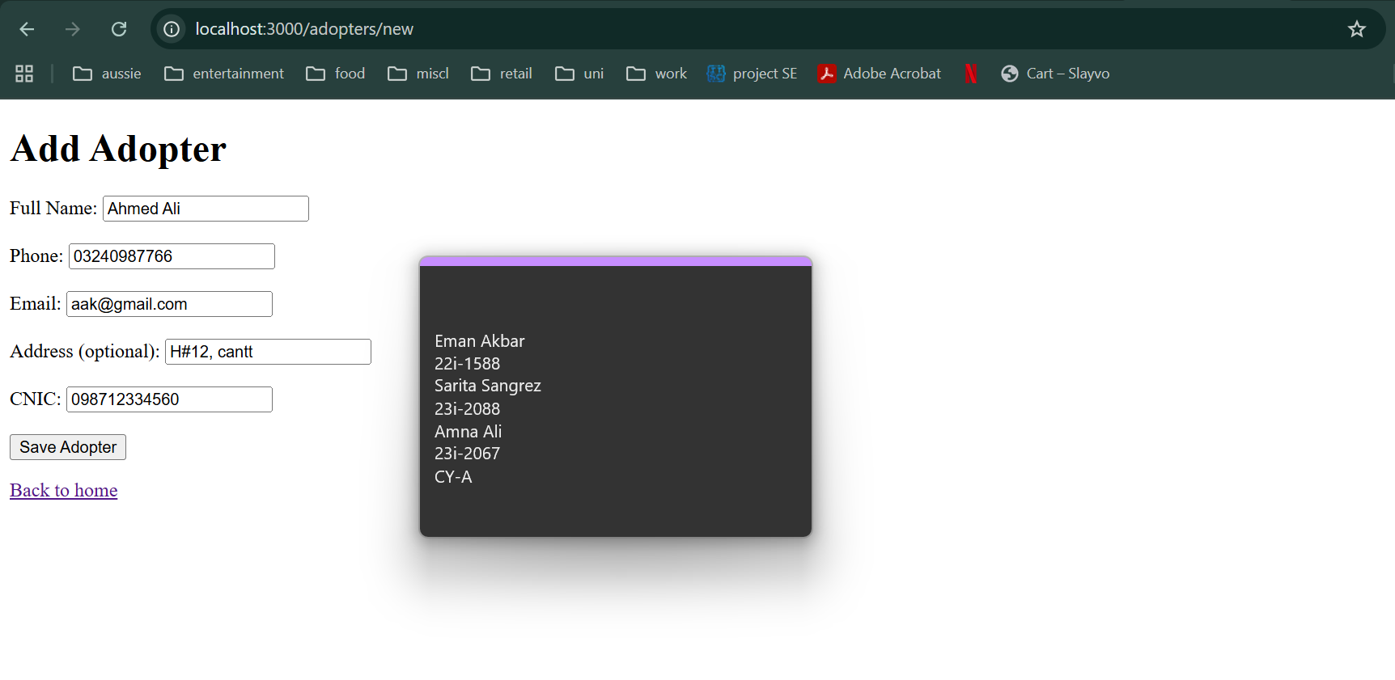
Validation check:
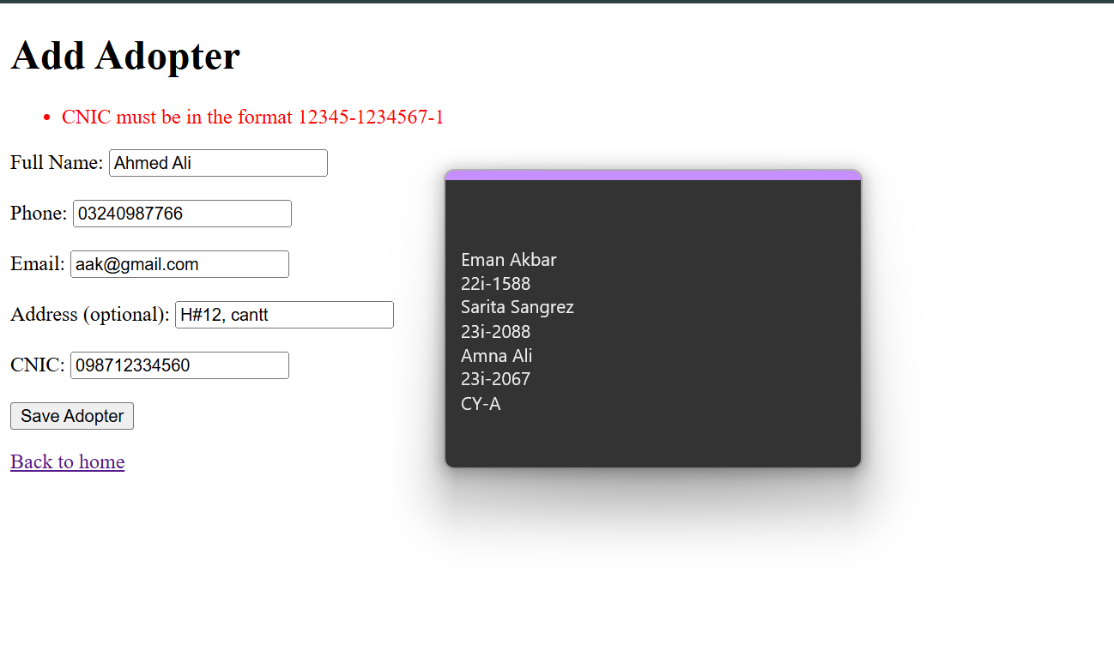
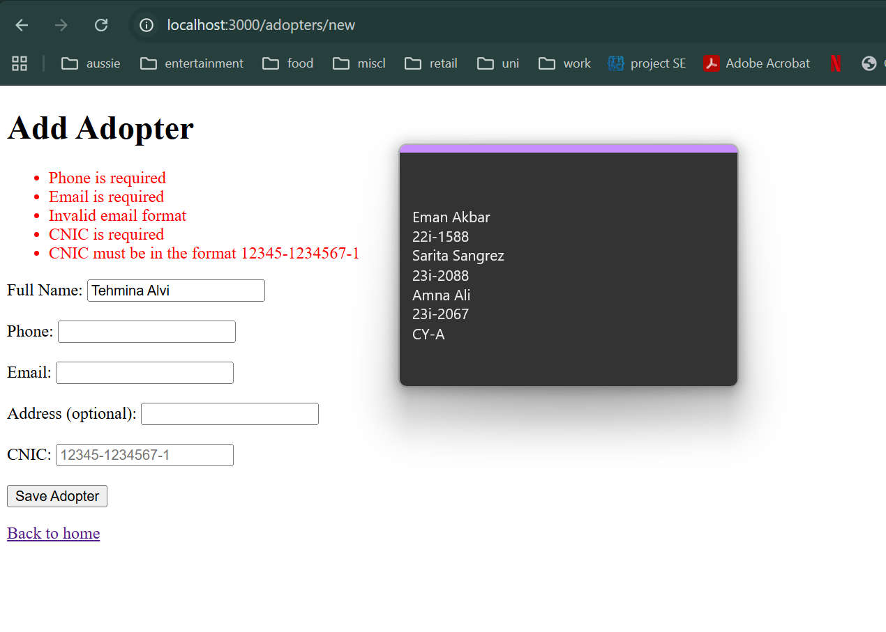

Appointment:
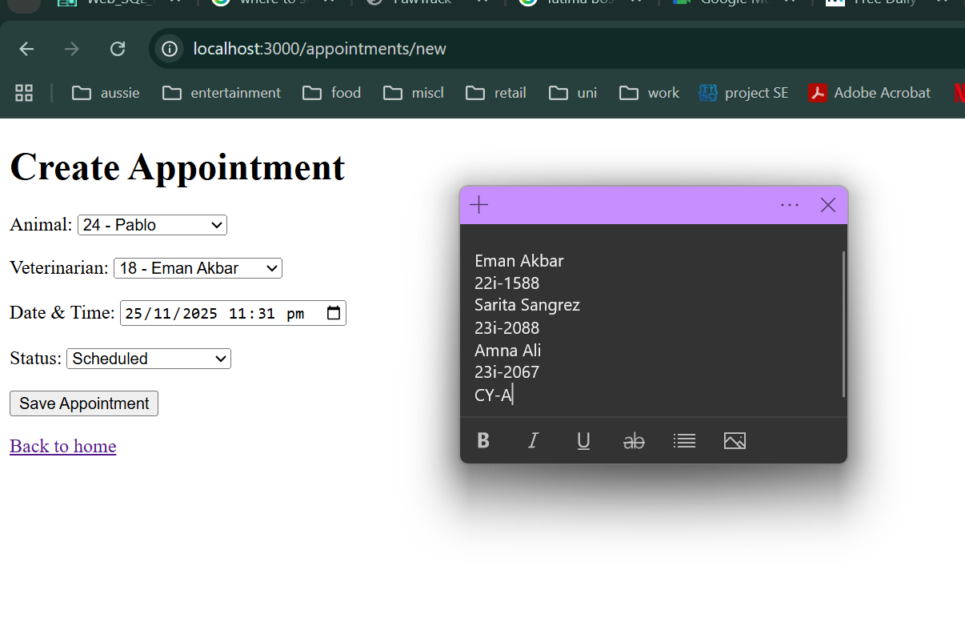
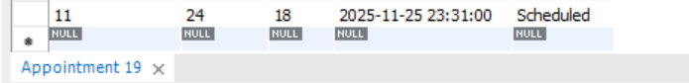
Validation check:
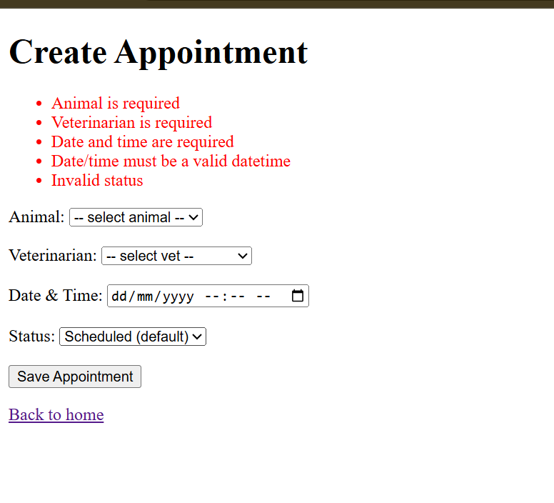
Treatment:
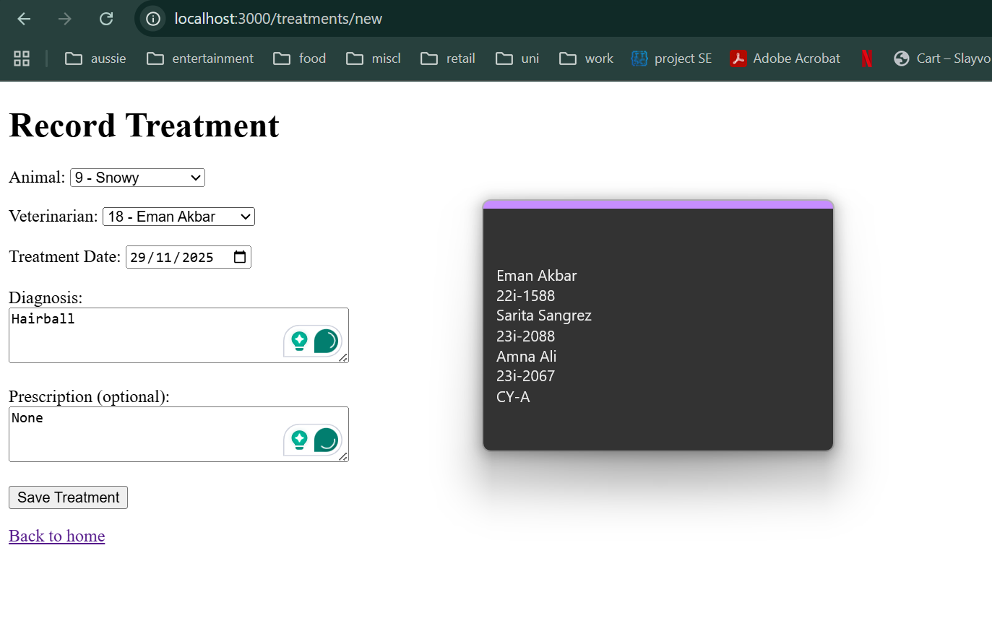

Adoption:
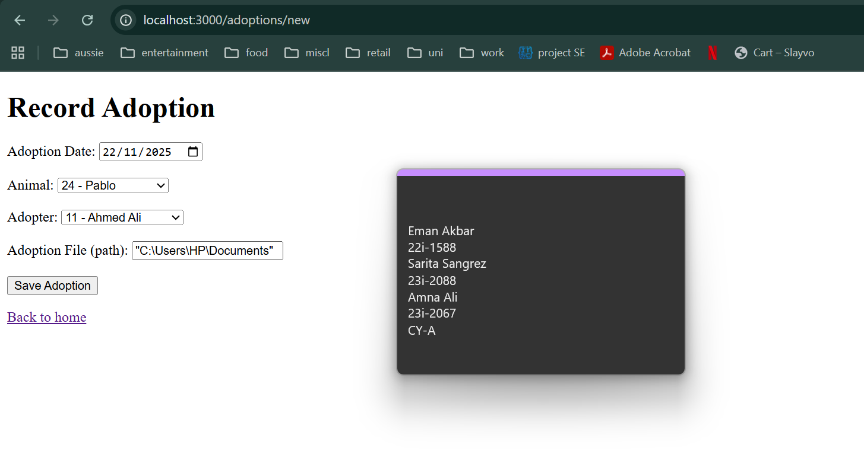

SECTION 4 — Screenshots & Evidence
4.1 Populated MySQL Tables
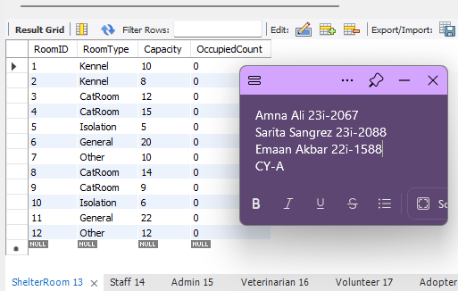
- All staff including the subtypes that are admin, vet and volunteer
- Used ‘echo -n "12345678" | sha1sum’ to compute hash for passswords
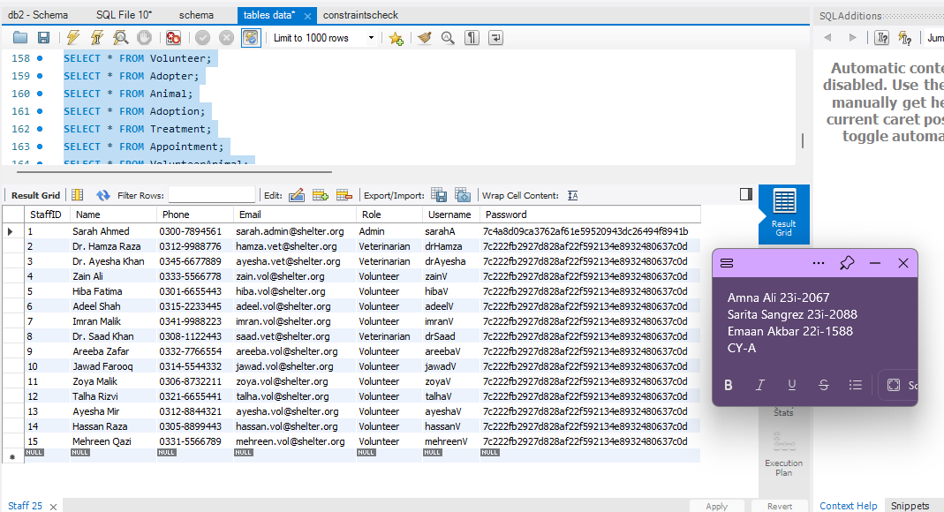
- Only one admin exists
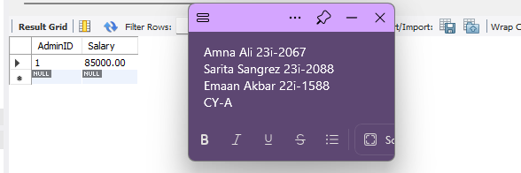
- 3 vets exist and the rest are volunteers as shown below
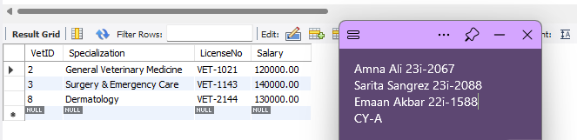
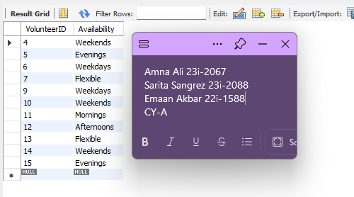

- Then we have all existing adopters with their information
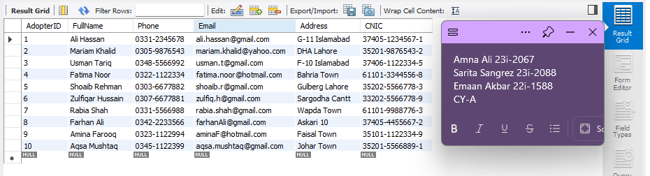
- List of all existing animals with their status
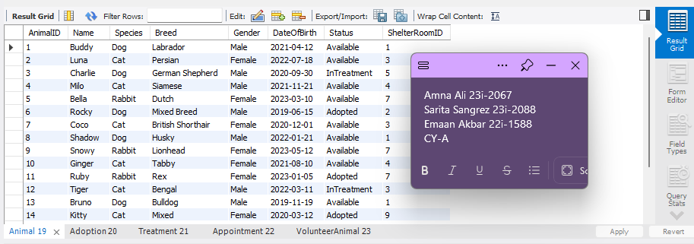
- AnimalIds 6,11,14 and 18 are adopted as u can see above which is also shown in adoption table.
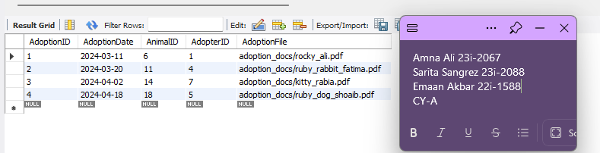

- Treatments and medical data assigned to veterinarians
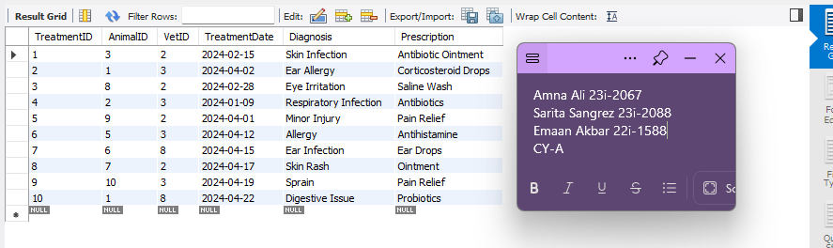
- Scheduled Appointments with proper status values
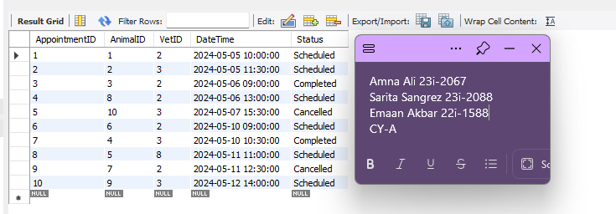
- Volunteer–Animal assignments representing the many-to-many relationship
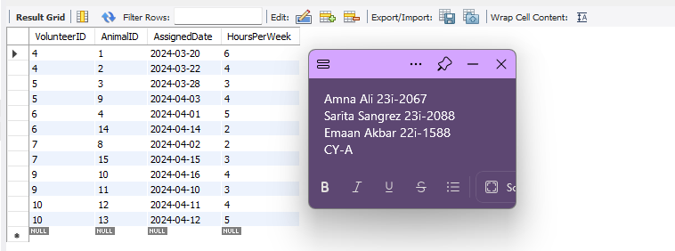
The screenshots of realistic dummy data demonstrate the correct implementation of referential integrity, domain constraints, and logical consistency across the relational model.

4.2 Constraint Validation Tests
To validate the schema we ran some test validation queries. These errors prove that database prevents inconsistent data.
- First constraint prevents adding an animal to adoption table as the id does not exit in animal table
- Second constraint ensures that the emails of staff are unique
- Third constraint checks that only defined species categories may be used (Lion is not added in the species enum in schema)
- Last constraint checks that hours per week should be greater than 0.
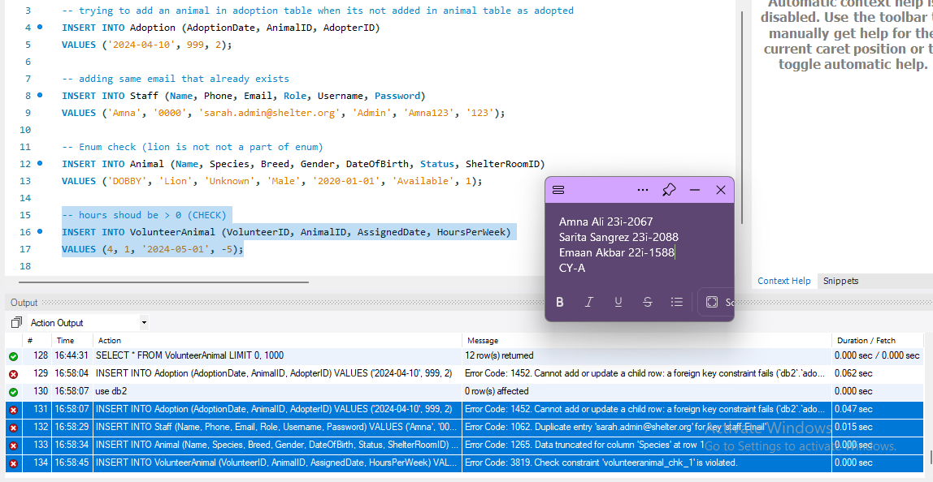

4.3 Successful Insertions
- Adding new adopter
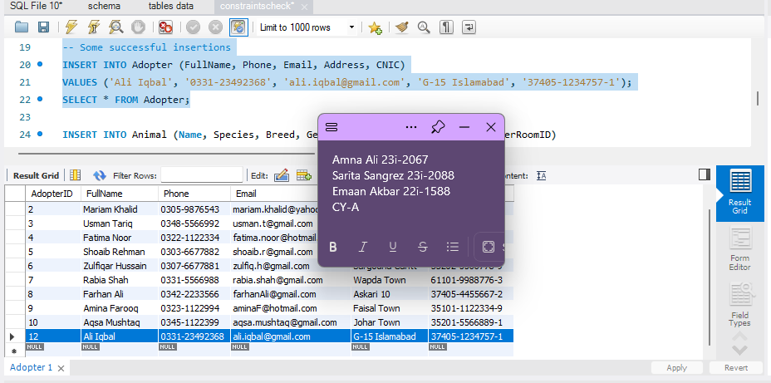
- Adding a new animal
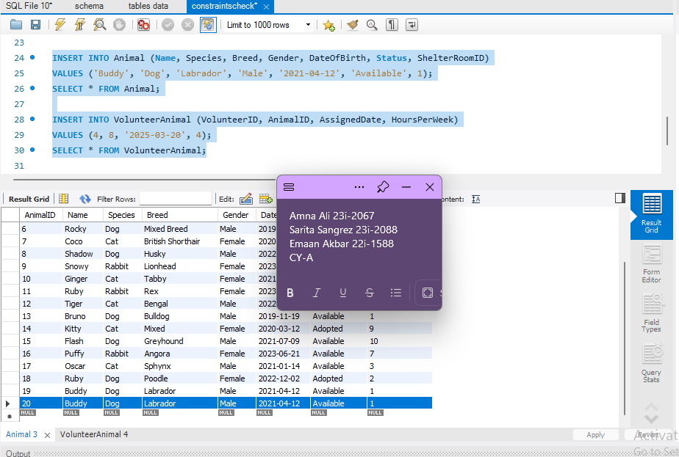

- And lastly assigning new volunteer
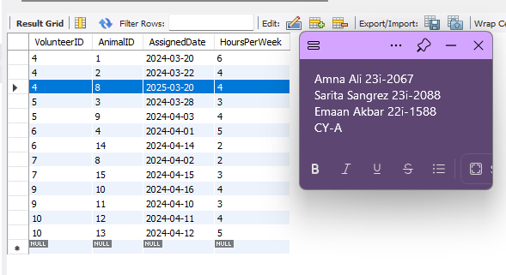
These confirm:
✔ Data meets constraints
✔ Schema is functional
✔ System behaves correctly

